FRONT END FULL STACK 201 - 202 -205 -206 IFMOTICA FES

***REACT TP 04*  composant class et fonction**

Objectif: utilisé Style-Gestion du routage

Exemple 1

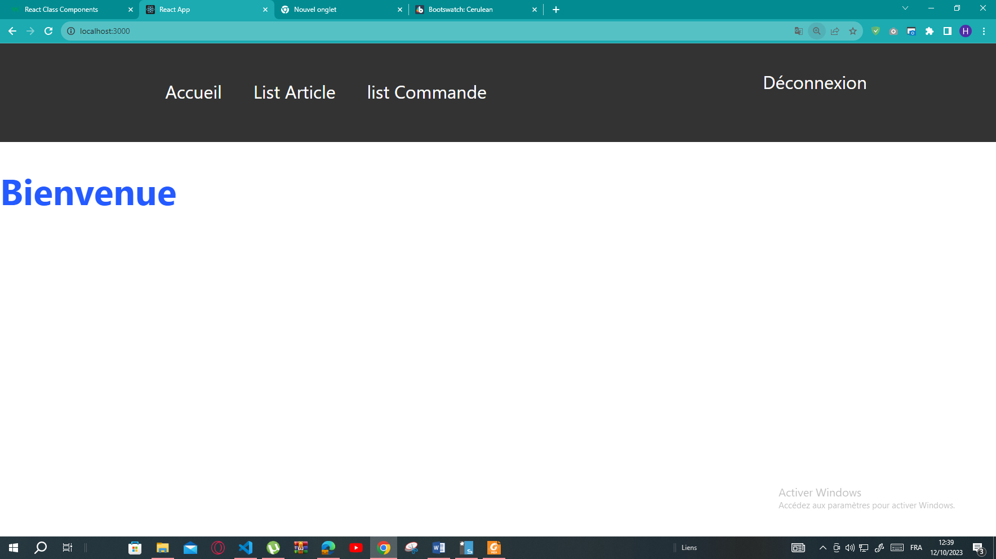

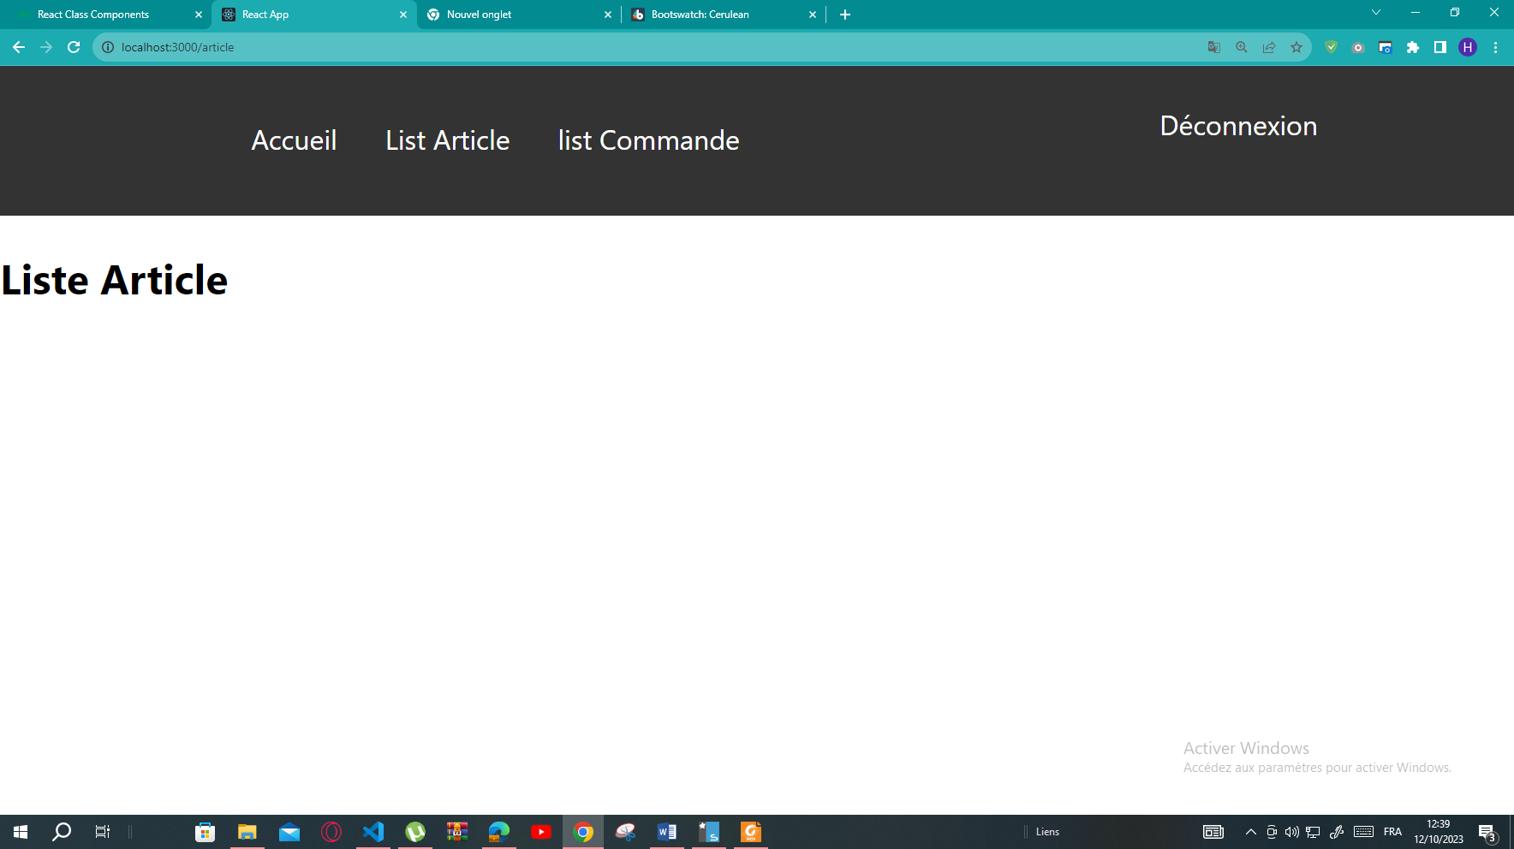

App.js

import React, { Component } from 'react';

import './index.css';

import { Routes, Route, Link } from 'react-router-dom';

class Appp extends Component {

    render() {

    return (

      <> <div class="scrollmenu">

        <div class="div1">

    <Link to="/">Accueil</Link>

    <Link to="/article">List Article </Link>

    <Link to="/commande">list Commande</Link>

  </div>

  <div  class="div2">

 <a href="connexion.php" >Déconnexion</a>

</div></div>

<div class="scrollmenu2">

    <Routes>

    <Route path="/" element={<Home />} />

    <Route path="/article" element={<Article />} />

    <Route path="/commande" element={<Commande />} />

    </Routes>

    </div>

    </>

    );

    }

    }

    class Home extends React.Component {

    render() {

    return (

    <div>

   <h1><font size="6" color="245aff">Bienvenue</font> </h1>

    </div>

    );

    }

    }

    class Article extends React.Component {

    render() {

    return (

    <div>

    <h2>Liste Article</h2>

    </div>

    );

    }

    }

    class Commande extends React.Component {

    render() {

    return (

    <div>

    <h2>Liste Commande</h2>

    </div>

    );

    }

    }

    export default Appp;

import React from "react";

import ReactDOM from "react-dom/client";

import App1 from "./App1";

import Appp from "./Appp";

import './index.css';

import { Routes, Route, Link } from 'react-router-dom';

import Voiture from "./Voiture";

import { BrowserRouter } from "react-router-dom";

const element = document.getElementById("root");

const root = ReactDOM.createRoot(element);

root.render(<BrowserRouter>

    <Appp />

    </BrowserRouter>);

div.scrollmenu {

  background-color: #333;

  overflow: *auto*;

  white-space: *nowrap*;

  position:*absolute* ;top:0% ;left:0%;width:100%;height:20%;float:*center*;

}

div.scrollmenu2 {

  background-color: #fff;

  overflow: *auto*;

  white-space: *nowrap*;

  position:*absolute* ;top:20% ;left:0%;width:100%;height:80%;float:*center*;

}

.div1{

    position:*absolute* ;top:20%; left:15%;width:70%;height:20%;float:*center*;

}

.div2{

  position:*absolute* ;top:10%; left:75%;width:20%;height:20%;float:*right*;

}

div.scrollmenu a {

  display: *inline-block*;

  color: *white*;

  text-align: *center*;

  padding: 14px;

  text-decoration: *none*;

}

div.scrollmenu a:hover {

  background-color: #777;

}